**Airplane mode of Wireless LAN automated testing**

**Version 1.0**

**Version History**

|  |  |  |  |
| --- | --- | --- | --- |
| **Version** | **Date** | **Handled by** | **Comments** |
| V1.0 | 27-May-2019 | ZL Chen | First version release. |
| V1.1 | 06-June-2019 | ZL Chen | Modify the airplane folder name |
| V2.0 | 12-June-2019 | ZL Chen | Second version release for WLAN. |

Precondition Setting:

Please make sure the DUT is connected to the internet.

* Install the adb interface driver
  + Please refer to the “ADB interface driver.pdf” attachment.

(\automation\sop\other\ADB interface driver.pdf)

* Install the Python 3.6.8.
  + Please refer to the “Python 3.6.8 installation.pdf” attachment.

(\automation\sop\other\Python 3.6.8 installation.pdf)

* Install the third party library.
  + Double click the “Envir_Install.exe” under the installer folder.

(\automation\installer\Envir_Install.exe)

Please follow the implement as below:

Block Diagram:

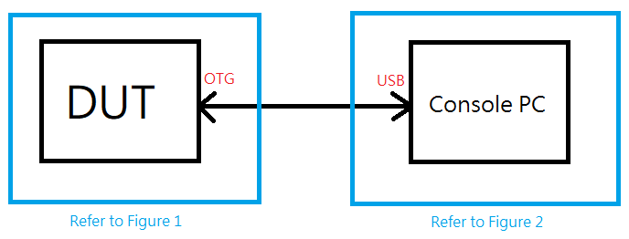

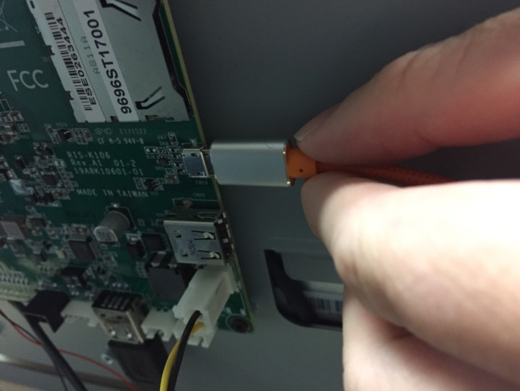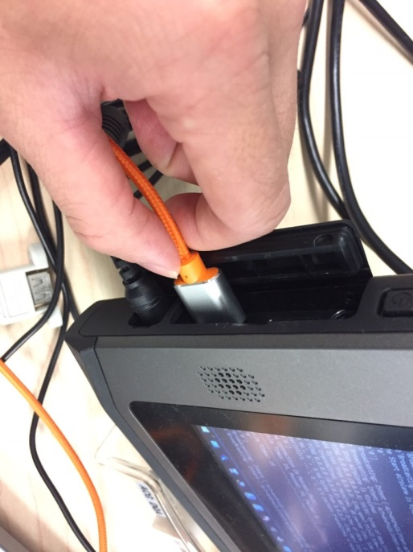

Figure 1 Figure 2

Step 1:

Please make sure the Wi-Fi is connecting to the repeater. (Figure 1)

SSID: siot_dqa

Password: ad20151225

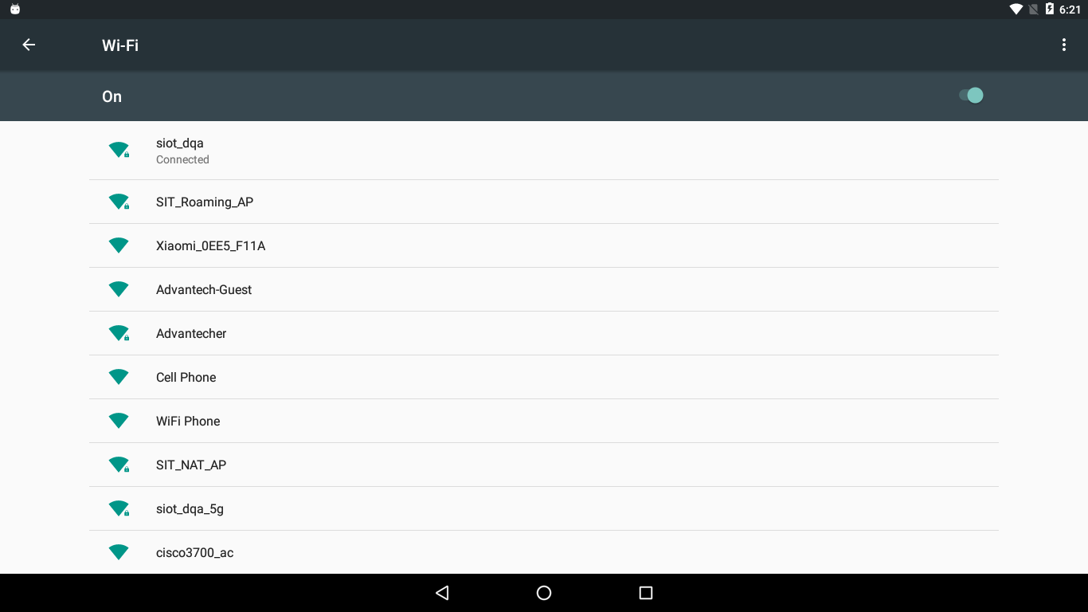

Step 2:

Please delete all of the known networks, because you need make sure the network just only attach to the “siot_dqa” repeater. (Figure 1)

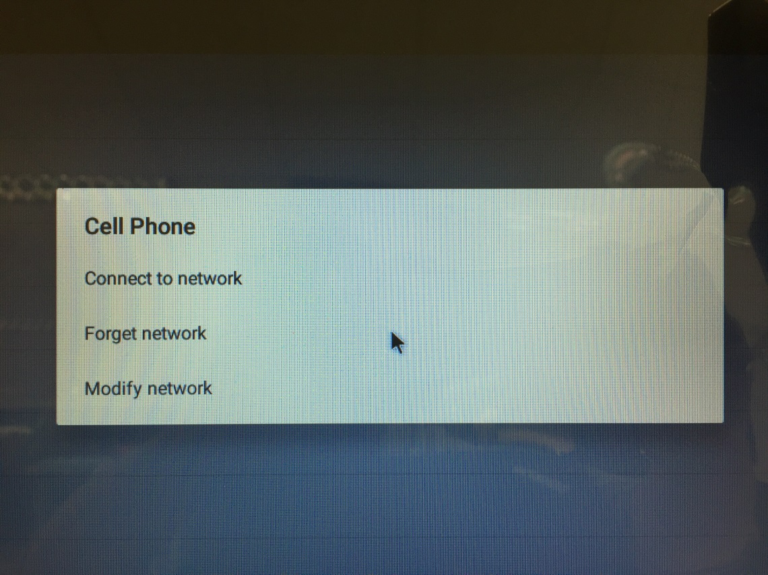

Step 3:

Please copy the airplane_wlan folder of the suite to the device’s desktop. (Figure 2)

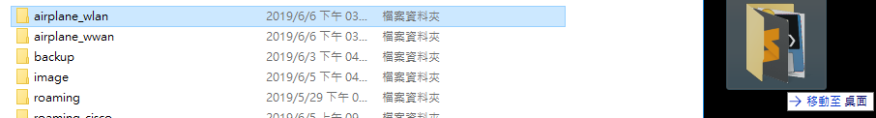

Make sure the adb.exe should be worked, so please input the window command as below: (Figure 2)

Command: “adb.exe kill-server” and “adb.exe start-server”

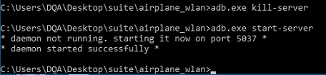

Command: “adb.exe devices”

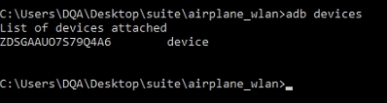

Make sure the “Allow USB debugging” alert is pop up on the DUT window. (Figure 1)

Please check the “Always allow from this computer” box, then tap the “OK” button.

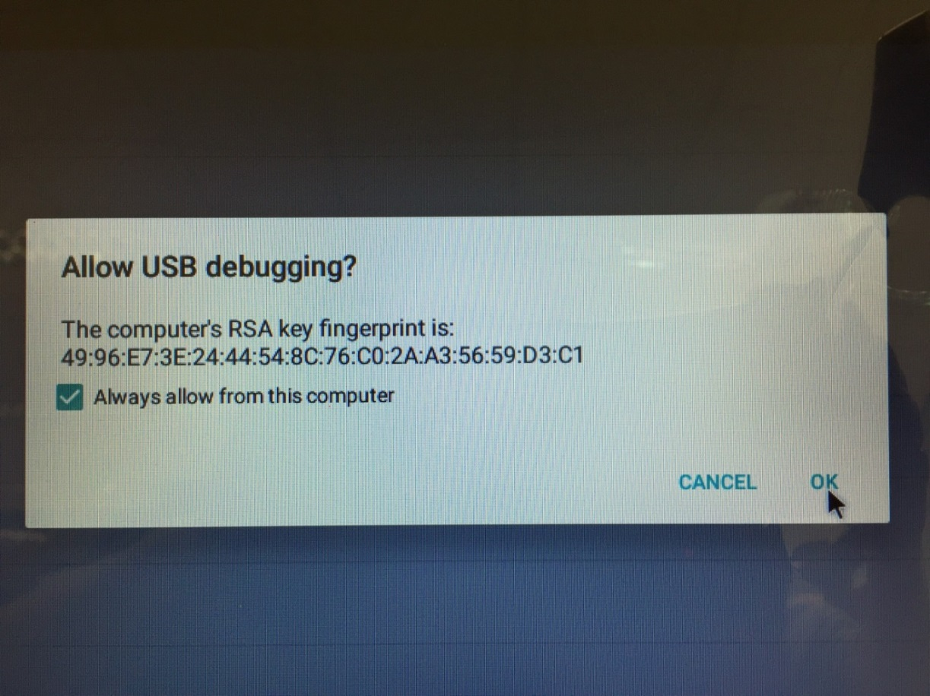

Implement the airplane_wlan.exe under the “\airplane_wlan\” folder. (Figure 2)

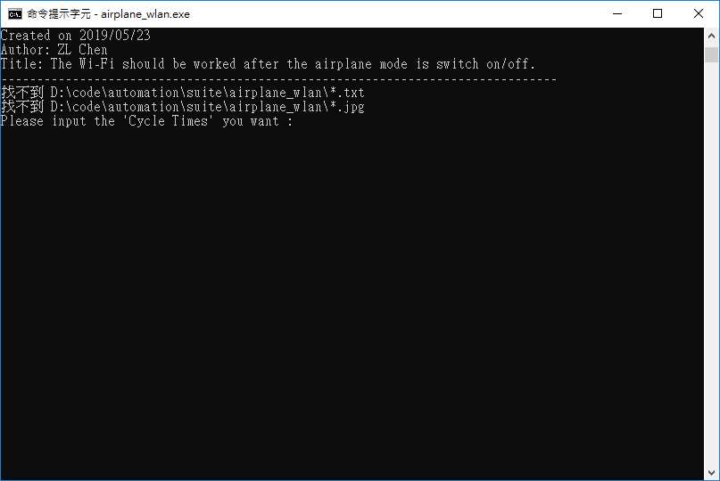

Step 4:

Please input the “Cycle Times” you want. (Ex: 1), and then tap the “Enter”. (Figure 2)

Please input the Gateway. (Ex: 192.168.31.1), and tap the “Enter”. (Figure 2)

The program is start running.

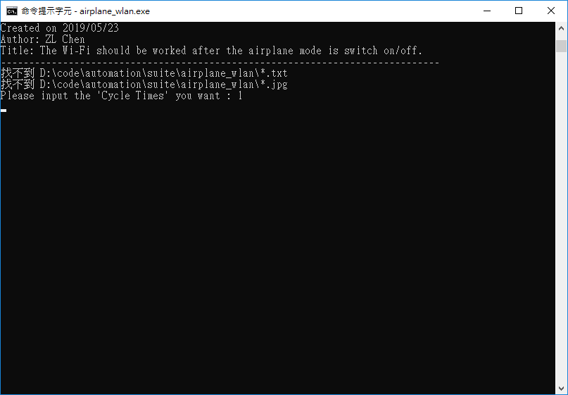

Step 5:

When the program is completed, the windows should be closed.

You can see the log under the “\airplane_wlan\” folder as below: (Figure 2)

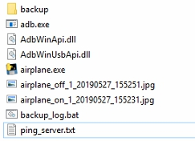

* ping_server.txt is ping log.

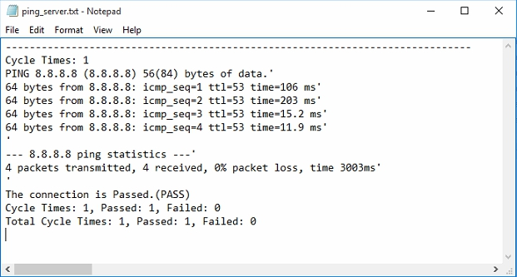

The Total Cycle Times is 1, Passed is 1 and Failed is 0.

* airplane_off_1_20190527_155251.jpg is airplane switch off by screenshot. 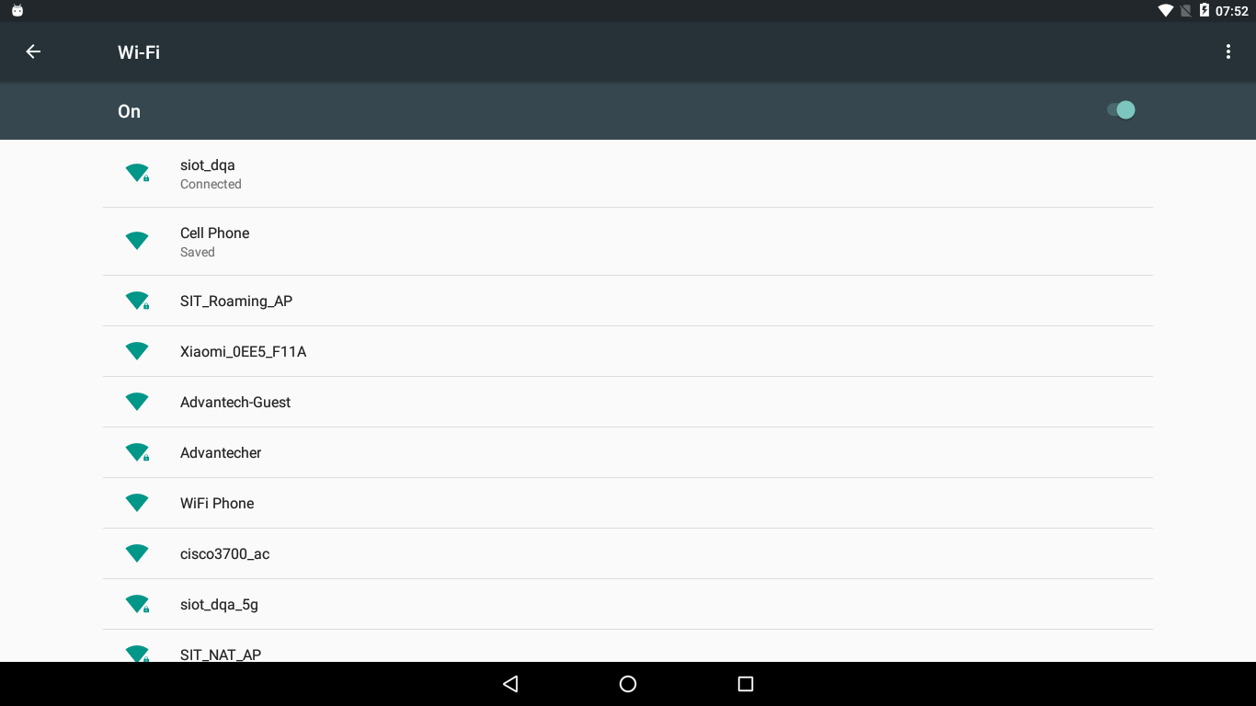
* airplane_on_1_20190527_155231.jpg is airplane switch on by screenshot.

